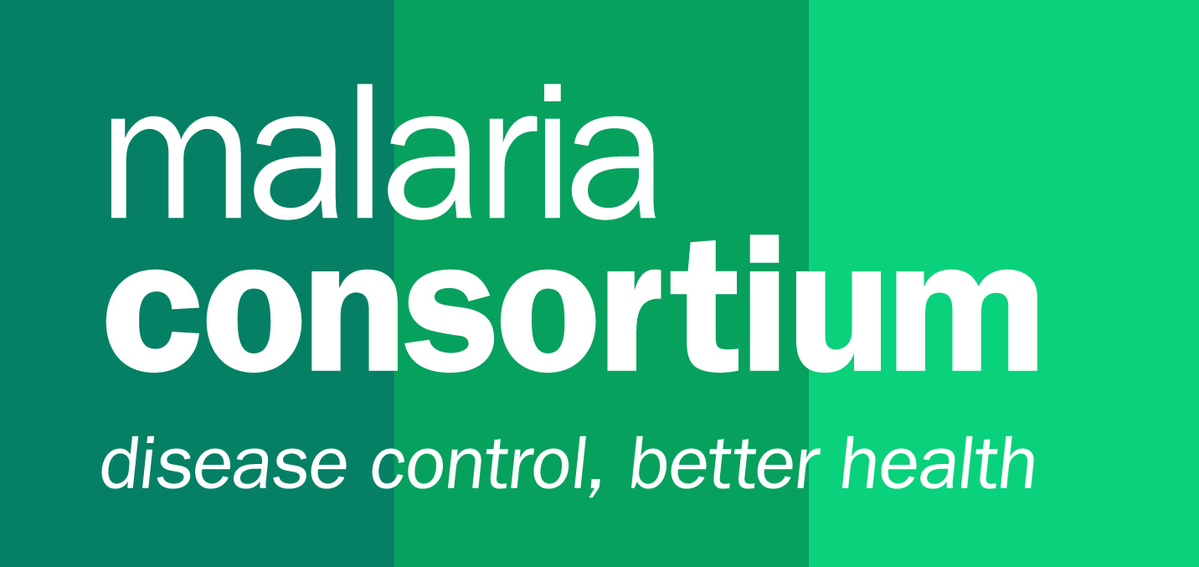 JOB DESCRIPTION

|  |  |  |  |
| --- | --- | --- | --- |
| **Job title:** | **Country Technical Coordinator** | **Location:** | **Togo** |
| **Department:** | **Technical** | **Length of contract:** | **2 years** |
| **Role type:** | **National** | **Grade:** | **10** |
| **Travel involved:** | **Up to 30% travel in Togo and abroad** | **Child safeguarding level:** | **3** |
| **Reporting to:** | **Country Director** | **Direct reports:** | **M&E and Research Officer and dotted line to (part-time) project officers** |
| **Dotted Line Manager** | **NA** |

Organisational background

Established in 2003, Malaria Consortium is one of the world’s leading non-profit organisations specialising in the comprehensive prevention, control and treatment of malaria and other communicable diseases among vulnerable and under privileged populations. We increasingly find our work on malaria can be effectively integrated with other similar public health interventions for greater impact and therefore expanded our remit to include child health and neglected tropical disease interventions.

We work in Africa and Asia with communities, governments, academic institutions, and local and international organisations, to ensure effective delivery of services, which are supported by strong evidence.

Our areas of expertise include:

* disease prevention, diagnosis and treatment
* disease control and elimination
* systems strengthening
* research, monitoring and evaluation leading to best practice
* behaviour change communication
* national and international advocacy and policy development

Country and Project background

To prevent malaria in those most vulnerable to the disease’s effects in areas where malaria transmission is seasonal, the World Health Organization (WHO) recommends seasonal malaria chemoprevention (SMC). SMC is the intermittent administration of monthly courses of sulfadoxine-pyrimethamine (SP) and amodiaquine (AQ), or SPAQ, to children between 3 and 59 months during the rainy season. Malaria Consortium has been a leading implementer of SMC since the WHO issued its recommendation to scale up the intervention in 2012. Currently, Malaria Consortium supports at-scale implementation of SMC in Burkina Faso, Chad, Nigeria and Togo, mainly using philanthropic funding received as a result of being awarded Top Charity status by GiveWell. In Togo, Malaria Consortium started supporting the Programme National de Lutte contre le Paludisme (PNLP) in 2020. We aim to work with government and partners to ensure high-quality delivery of SMC to over 500,000 children in Centrale, Karand Savanes regions.

To assess our performance and to support decision-making, we routinely track the quality of programme delivery, coverage, efficacy, safety, drug resistance, impact and cost. Specifically, this involves collecting and analysing administrative data, conducting household surveys and scrutinising stock consumption data. In addition, Malaria Consortium conducts research on selected SMC-related topics to maximise efficiency, drive innovation and demonstrate impact.

Currently, in collaboration with the PNLP, Malaria Consortium Togo is implementing several key interventions, including iCCM integrating SMC, research on Zero Dose children (those not vaccinated or not up to date with their required vaccinations), and C-IPTp. These initiatives highlight the critical need to build the capacity of the PNLP in leading malaria programming. Strengthening their ability to liaise with other MDAs, coordinate with partners, and mobilise resources—including government resources—is essential for the success of Malaria Consortium Togo's efforts. By enhancing these capacities, Malaria Consortium Togo aims to ensure more effective malaria control and ultimately improve health outcomes in the communities served.

**Job purpose**

The Country Technical Coordinator will provide technical oversight and support to programmes in Malaria Consortium’s Togo office, ensuring the integration of up-to-date knowledge and best practices in implementation. Acting as a credible technical partner to the PNLP, the Coordinator will leverage research to inform programme strategies and foster an internal learning process that drives continuous improvement across all initiatives.

Scope of work

The position holder will be responsible for guiding all projects and programmes within Malaria Consortium Togo's portfolio, working to position the organization as the technical lead on SMC and community health. This includes developing a comprehensive research strategy focused on identifying and addressing gaps in malaria interventions, such as projects like iCCM integrating SMC, Zero Dose, and C-IPTp. The position holder will develop research protocols that align with national health priorities and engage stakeholders, ensuring that findings inform programme design and policy recommendations. By integrating research into the operational framework, Malaria Consortium Togo aims to enhance its impact on malaria control and improve health outcomes in the communities served. Develop a country-level M&E framework. Lead on national technical coordination and represent MC in key forums and engage with programme-level technical working groups. S/he will also provide technical inputs to the Ministry of Health and other key stakeholders on tools and policies, including MC assured SMC quality standards are incorporated in national strategy and practice, and oversee SMC quality improvement through verification and develop technical implementation materials for training and supervision. Develop and/or support the development of technical publications. Provide technical oversight to Malaria Consortium research teams in country. Also, provide technical inputs to research ideas and opportunities and to the writing of funding proposals.

Key working relationships

The CTC will have a dotted reporting line to the Senior Malaria Technical Specialist for the region but report directly to the Country Director (CD). S/he will collaborate closely with the regional and global technical teams, the country programmes team, and external stakeholders on various technical areas. This includes identifying capacity-building needs for the PNLP, developing a capacity-building plan for the PNLP and its partners, and establishing a timeline for implementing technical assistance and executing the plan with appropriate monitoring mechanisms. Additionally, s/he will develop, set up, and maintain Technical Assistance and Quality Assurance systems for the country office, facilitating the transition of technical capacities from Malaria Consortium to the PNLP for community health services. S/he will also provide support to the partners involved in the transition and document the entire process.

Key accountabilities

### Strategic accountability (20%)

* Work with the Country Director in business development, including identification of potential areas of research relevant for Malaria Consortium and write new concept notes and funding proposals.
* Take lead, as required, on the technical aspects of proposal development in accordance with donor tender documentation and requirements.
* Provide strategic planning support to the Country Director. Specifically, contribute to the strategic development of Malaria Consortium’s work in the country including the conduct of needs assessments and exploration visits, the provision of technical leadership in the design of projects and the planning of implementation

### Technical accountability (50%)

* **Delivery**
* Monitor programs to ensure all are implemented with high technical quality, based on evidence and best practices. Identify necessary improvements and communicate these to program staff and the Country Director.
* Coordinate the identification of technical support needs for programs and collaborate with the global technical team, primarily the Head of Technical Operations for West and Central Africa and the Technical Operations Coordinator, to ensure timely and high-quality technical support.
* Support the Monitoring and Evaluation (M&E) Manager in developing M&E plans and utilizing M&E tools and systems to enable the use of data for creating learning briefs and technical documents based on program activities.
* Provide technical support to key stakeholders, including the Ministry of Health, in the development and review of strategies and policies related to communicable disease control.
* **Research**
* Contribute to the identification, selection, and oversight of research activities to be undertaken in the country by Malaria Consortium staff and/or short-term technical assistance.
* Apply an understanding of qualitative and quantitative research methodologies to support robust research activities.
* Actively participate in West and Central Africa Technical Team activities, including regular calls with the Head of Technical Operations and other team communications, to create and sustain a strong regional technical entity.

### Recruitment and development of Technical staff (10%)

* Support the Country Director to identify technical resource gaps in the office and provide input to the recruitment of technical staff.
* Line manage M&E manager and have dotted line management of field officers

### Documentation, Reporting and Communication (10%)

* Periodically report to the Country Director on the technical progress of programmes and highlight any critical technical issues.
* Participate in the writing of learning, technical or policy briefs on key technical topics.
* Contribute to advocacy materials development.

### Programme Management (5%)

* Act as Principal Investigator on key research studies, when relevant and when necessary.
* Act as budget holder on key programmes or research studies as agreed with the Country Director when relevant.
* Manage multiple projects simultaneously with competence in planning, execution, and evaluation.

### Representation (5%)

* Represent Malaria Consortium at regional and international meetings/workshops on specific technical areas, including relevant networks.
* Represent Malaria Consortium in technical meetings with donors, coordination bodies and Government representatives, as required.
* Engage proficiently with a diverse range of stakeholders, including government agencies, NGOs, and community organizations.

Person specification

*Qualifications and experience:*

### Essential:

* Master’s degree in Public or International Health, Communicable or Infectious diseases, Epidemiology or related discipline.
* Extensive experience designing and working in public health programmes or communicable disease control, with significant experience in a senior role.
* Highly knowledgeable about malaria control, communicable diseases and nutrition and/or direct experience working in these areas.
* Field experience in Sub-Saharan Africa and a solid understanding of the realities and complexities of programme implementation.
* Demonstrable experience working in a technical advisory capacity to Ministries of Health and other partners, including relating to policy and guidelines review or development, and programme reviews.
* Business development, including needs assessment, the development of concept notes and proposals, and stakeholder consultation and analysis
* Professional working proficiency of French and English (both written and spoken)

### Desirable:

* Experience in conducting qualitative and quantitative research related to public health programmes
* Experience in health systems strengthening
* Experience of building effective working relationships between MoH and its stakeholders
* Project or programme management including design, planning, implementation, monitoring and evaluation
* Business development, including needs assessment, the development of concept notes and proposals, and stakeholder consultation and analysis
* Experience working with teams with diverse cultural and professional backgrounds
* Experience in strategic planning and strategy implementation
* Experience managing projects or programmes funded by major institutional donors and agencies such as DFID, USAID, the UN or EU
* Financial management and/or experience of working with large budgets

## Work-based skills and competencies:

### Essential:

* Strong communication, interpersonal and presentation skills, with strong stakeholder management skills, able to engage effectively with broad and diverse audience
* Strong leadership skills with inclusive and motivational style and strong influencing ability
* Strong problem-solving ability, with excellent planning and organizational skills
* Excellent written and spoken English and French
* Strong technical writing skills
* Strong computer skills, conversant with MS Office packages
* Self-motivated, proactive and results-focused
* Able to work effectively as part of a team and on own initiative, with ability to work to deadlines whilst being attentive to detail

### Desirable:

* Demonstrable data management and statistical analysis skills
* Basic security & communications training

|  |
| --- |
| **Core** **competencies**: |
| **Delivering results** |
| **LEVEL C - Supports others to achieve results:**   * Displays a positive and enthusiastic approach and is not deterred by setbacks, finding alternative ways to reach goals or targets. * Supports others to plan and deliver results * Supports others to manage and cope with setbacks |
| **Analysis and use of information** |
| **LEVEL** **C- Works confidently with complex data to support work:**   * Interprets complex written information * Works confidently with data before making decisions: for example; interpreting trends, issues and risks * Acquainted with the validity, relevance and limitations of different sources of evidence |
| **Interpersonal and communications** |
| **LEVEL C** - **Adapts communications effectively:**   * Tailors communication (content, style and medium) to diverse audiences * Communicates equally effectively at all organisational levels * Understands others’ underlying needs, concerns and motivations and communicates effectively in sensitive situations * Resolves intra-team and inter-team conflicts effectively |
| **Collaboration and partnering** |
| **LEVEL C -** **Builds strong networks internally and participates actively in external networks and think tanks:**   * Builds strong networks internally * Participates actively in external networks and/or think tanks. * Engages with relevant experts to gather and evaluate evidence * Shares and implements good practice with internal and external peers |
| **Leading and motivating people** |
| **LEVEL C – Effectively leads and motivates others or direct reports**   * Gives regular, timely and appropriate feedback, * Acknowledges good performance and deals with issues concerning poor performance * Carries out staff assessment and development activities conscientiously and effectively * Develops the skills and competences of others through the development and application of skills * Coaches and supports team members when they have difficulties |
| **Flexibility/ adaptability** |
| **LEVEL D -** **Supports others to cope with pressure:**   * Responds positively to change, embracing and using new practices or values to accomplish goals and solve problems and supports others to do the same * Adapts team approach, goals, and methods to achieve solutions and results in dynamic situations * Sets realistic deadlines and goals for self or team |
| **Living the values** |
| **LEVEL C -** **Supports others to live Malaria Consortium’s values:**   * Demonstrates personal integrity by using role position responsibly and fairly * Cultivates an open culture within the wider team, promoting accountability, responsibility and respect for individual differences |
| **Strategic planning and thinking and sector awareness** |
| **LEVEL C -** **Keeps up to date with the internal and external environment:**   * Takes into account economic, political and other business factors when drawing up medium and long-term plans, covering both public and private sectors, * Looks beyond the immediate operations to prospects for new business, * Engages with appropriate internal and external sources to establish major influences on future plans |