

APPLICATION FORM

FIGHT AGAINST AVOIDABLE BLINDNESS

- Application deadline: February 28, 2019
- Annoucement of the supported projects: March 20, 2019
- Signature of the partnership agreement: April, 2019

PURPOSE

L’OCCITANE CARES ABOUT SIGHT!

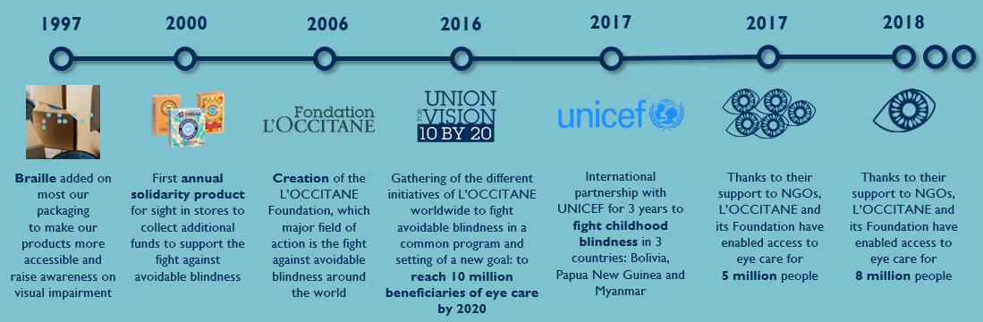

The L’OCCITANE Foundation launches a call for projects to fight avoidable blindness and encourages L’OCCITANE’s offices worldwide to participate by identifying and supporting local organizations with eye care projects.
These projects are co-financed by L’OCCITANE’s local offices and by the Foundation. The Foundation will double* the funding granted by L’OCCITANE’s local offices.
*In the limit of €5,000, €10,000 or €20,000 depending on the country; but the local L’OCCITANE’s office can support the project with more funding

RULES & ELIGIBILITY CRITERIA

- The project needs to be carried out by an organization of general interest
- The project must focus on eye care (screenings sessions, provision of spectacles, treatments, surgeries, optometrists or ophthalmologists training, purchase of machinery and equipment, etc).
- The project needs to have measurable results. The number of beneficiaries receiving eye care thanks to the help of L’OCCITANE must be included in at least one of the lines of the table in 1.10 part of the following application form.
- A strong focus will be done on the financial sustainability of the project
- Location (in order to facilitate the relationship with the local L’OCCITANE office):
- The project presented takes place in a country where there is a local L’OCCITANE’s office
AND / OR
  - The charity organization managing the project and requesting the grant has a local office in a country where there is a local L’OCCITANE’s office
(see countries ‘list here under)
- Depending on the location, the average requested grant will be:
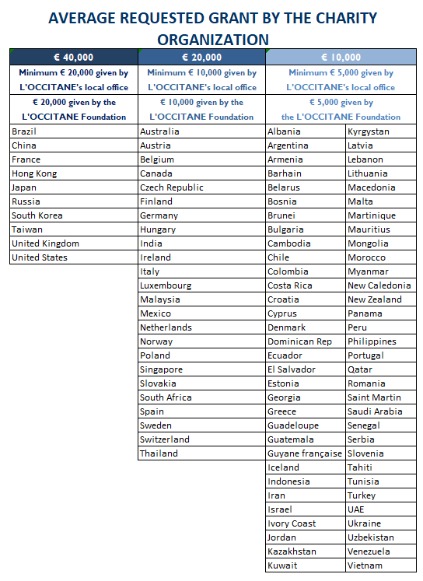

[Maximum 8 pages in total]

Summary

Name of the organization:
Country where the project takes place / the beneficiaries are:
Brief summary of the project:

Total requested grant (in €) (= financial support given by the local L’OCCITANE’s office + financial support given by the L’OCCITANE Foundation):

THE ORGANIZATION

Name of the organization

Field of action / Specialty

Type of organization and global mission
3 lines max

First name and surname of the legal representative

Key funding sources of the organization
3 lines max

Number of years in operation

Address

E mail

Phone number / Country code

Does it have an office in France or in Europe?

THE PROJECT

- PRESENTATION

1.1 Name of the project / program

1.2 Description
5 lines max

1.3 Location

1.4 Duration of the project

1.5 How is your project answering a need of general interest?
3 lines max

1.6 Global context (geographic, politic, economic, social …)
5 lines max

1.7 Global project in which your project is included (optional)
3 lines max

1.8 Detailed project description. What activities will you carry out?
15 lines max

1.9 Originality of the project
5 lines max

1.10 Number of beneficiaries who will receive eye care thanks to the help of L’OCCITANE:
1
11
2
11
1+2
 |  | CHILDREN  < 18 years old | ADULTS | TOTAL
DURING THE FUNDED PERIOD
NUMBER OF BENEFICIARIES SCREENED (1) |  | ..….. | ..….. | ..…..
 | Among the total number of beneficiaries screened,  number who received treatments | ……. | ……. | …….
 | Among the total number of beneficiaries screened,  number of beneficiaries who received surgeries | ……. | ……. | …….
 | Among the total number of beneficiaries screened,  number of beneficiaries who received prescriptions glasses | ……. | ……. | …….
NUMBER OF MEDICAL STAFF TRAINED |  |  |  | ..…..
NUMBER OF MACHINE(S) BOUGHT |  |  |  | ..…..
AFTER THE FUNDED PERIOD
NUMBER OF FUTURE BENEFICIARIES BY 2020 (INCLUDED) (2)  THANKS TO THE FUNDED TRAINING and/or MACHINE  Ex: if you estimate that 1 medical staff trained screens 50 patients per year,  he /she will screen 150 patients in 3 years |  | ……. | ……. | .…..
TOTAL = DURING THE FUNDED PERIOD + AFTER THE FUNDED PERIOD
TOTAL NUMBER OF BENEFICIARIES SCREENED DURING THE FUNDED PERIOD + NUMBER OF FUTURE BENEFICIARIES BY 2020 THANKS TO THE FUNDED TRAINING AND/OR MACHINE(s) (1+2) |  | ……. | ……. | ..…..
/!\ We consider as beneficiaries the number of people who are at least screened
/!\ Every person who receives a treatment / surgery / glasses is usually screened before,
so he/she counts only for 1 beneficiary (should not be counted twice).

1.12 Goals / Results expected

1.13 Means implemented to measure the expected results and impacts

- PROJECTED CALENDAR OF THE ACTIONS FOR THE YEAR

Please, insert your calendar / action plan
HERE

2.1 Risks that might modify the calendar
5 lines max
2.2 Forecast actions to face them
5 lines max

- DURATION AND PROJECT SUSTAINABILITY

3.1 Continuation & sustainability of the project
5 lines max

3.2 Relationships with local partners, national authorities and other programs
5 lines max

3.3 Fallback strategy & project autonomy
5 lines max

3.4 Self-financing long term strategy
5 lines max

3.5 Scalability
3 lines max

BUDGET
 | Amount (in €) | in %
Total project’s budget |  | 100%
Total L’OCCITANE’s requested grant
part of L’OCCITANE’s office | to be filled by L’OCCITANE | to be filled by L’OCCITANE
part of the L’OCCITANE Foundation | to be filled by L’OCCITANE | to be filled by L’OCCITANE
Other funding / financial support

Please note that the financial transfers will be made between April 1, 2019 and March 31, 2020.

- Please insert your detailed budget in € with the detailed expenses

(explain how the requested grant will be used)

Activity/Detailed Items | Details of Cost Estimates
Activity/Detailed Items | Unit Cost (€) | Basis of Calculation | Unit | Total budget (€)
 | - € |  |  | - €
 | - € |  |  | - €
 | - € |  |  | - €
 | - € |  |  | - €
TOTAL REQUESTED GRANT |  |  |  | - €

- Do you have others parties involved? If so, please list them

COMMUNICATION

Please insert your logo
Here

Please insert some pictures of the project (if you already have some) or of some other similar project:
Here

Communication actions planned around the project & L’OCCITANE:
5 lines max

L’OCCITANE’s LOCAL OFFICE (to be filled by L’OCCITANE)
Which L’OCCITANE’s office will be involved in the project?
Name and country
Number of employees in the L’OCCITANE’s office

Number of employees that will be involved in the project

Who will be responsible for the project follow up?
name, title, email, phone number

