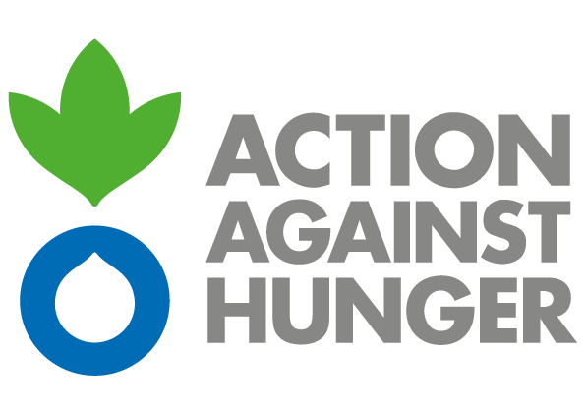 | Action Against Hunger  Mission Nigeria

CALL FOR FRAMEWORK AGREEMENT FOR BOREHOLE DRILLING AND CONSTRUCTION

Action Against Hunger tackles the causes and effects of hunger and diseases that threaten the lives of vulnerable children, women and men.
Established in France in 1979, Action Against Hunger are a non-governmental, non-political, non-religious, non-profit organisation.

Action Against Hunger - Nigeria intends to award some Framework Agreement for humanitarian programs in Nigeria for:

FD-ABU-02421: Framework Agreement for Borehole Drilling and Construction

Bidding documents can be obtained by interested parties from the email address below between the hours of 9:30 am -4:00 pm Monday to Friday clearly providing the following information: Company Name, Name of Chief Executive Officer of company, Address, Phone Number, Email.
tender-enquiry@ng-actionagainsthunger.org

Submissions will be delivered in hard copy sealed envelopes to one of the below addresses:

Action Against Hunger Office Addresses :

Address: Action Against Hunger- Abuja
N0. 3 Adamu Ciroma Crescent Off Ebitu Ukiwe Jabi District Abuja – Nigeria

Address: Action against Hunger- Maiduguri
No. 8 Bitam Street, off Circular Road ,Old GRA, Maiduguri Borno State- Nigeria

Address: Action against Hunger- Potiskum
Beside Army Day Government School, Shagari Low Cost, Gashua Road, Potiskum, Yobe State- Nigeria

Address: Action against Hunger- Sokoto
Opp. Blue Cresent Nursery School, Bakura Road, Mabera, Sokoto State, Nigeria

Note: Bidding documents will be available at the above location from Thursday 18th May, 2023.

Action Against Hunger does not bind itself to award the tender to the lowest tender or any bid and reserves the right to accept the whole or part of the tender

Electronic version will not be accepted.

The deadline for submission of tenders is 7th June, 2023 at 5pm, local Nigerian time.

