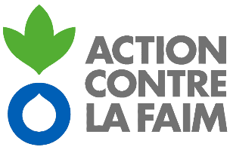
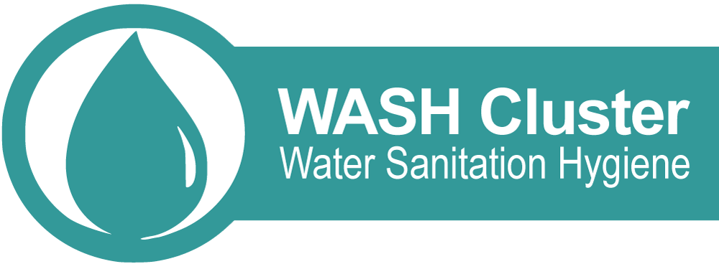

Sub-National WASH Sector Coordinator north east syria

Action contre la Faim is currently coordinating with UNICEF the Global WASH Cluster Field Support Team project.
Summary
Location: Syria (North East)
Department: Water, Sanitation, and Hygiene
Type of contract: Service Contract
Assignment type: Consultancy
Action Contre la Faim focal point: Jean Lapegue jlapegue@actioncontrelafaim.org
Duty station: Qamishli, with travel to the field
Languages required: English, Arabic would be advantageous
Technical requirements: proven experience in WASH Cluster Coordination, either National or Sub-national
Starting date: 15st May 2021

PURPOSE AND OBJECTIVES OF THE consultancy

Rational for the consultancy / background
Despite overall slight improvement of WASH conditions in Syria, vast WASH related needs persist in many parts of Syria1. This situation is exacerbated in NES where investments in the sector were already low prior to the crisis and where the impact of the crisis was especially severe. Even though the combined population in NES only represents 12 per cent of the overall Syrian population, about 21 per cent (2.2 million people) of the overall number of people in need of WASH services are located there. In addition, the NES governorates host a high number of IDPs, which are amongst the most vulnerable population in the country and often solely rely on humanitarian aid. Interviewees in IDP sites very often reported water insufficiency (37 per cent) or having barely enough water.

Sanitation needs are also significantly higher among people living in these IDP sites compared to the rest of the population, with 65 per cent of households reporting issues with sanitation such as over-crowding, lack of sex segregation, cleanliness, lack of locks or lights, and harassment. Substandard conditions of sanitation facilities are particularly concerning for women and girls, due to greater risks of sexual harassment, sexual violence, humiliation, physical violence and exploitation they face and adoption of harmful menstrual hygiene behavior.

In addition, a large proportion of households in these IDP sites indicated not being able to access one or multiple hygiene items in the previous month at the time of the assessment, including sanitary pads.
The Turkish offense in October 2019 in NES (Operation Peace Spring) further compounded WASH challenges in NES as several critical civilian infrastructures were damaged following military operations in the Tell Abyad- Ras al-Ain corridor. Additionally, the ongoing Corona virus disease 2019 (COVID19) pandemic, and with 14820 cases and 975 deaths reported by the Ministry of Health (as of 13 February 2021), has also impacted WASH programming and prioritization in Syria.

Against the above backdrop, the sustained implementation of a coordinated assistance remain critical in the provision of WASH services to affected communities. In this regard, the support of the sub-national WASH Sector Coordinator is crucial in ensuring effectively and timely implementation of UNICEF and partners’ response to issues outlined above.

Objectives of the consultancy
In line with UNICEF’s CCC and its mandate as WASH Sector lead in Syria (within the Government of Syria controlled areas), UNICEF has specific responsibilities to ensure continued effective WASH sector coordination to the WASH humanitarian response. Considering the scale of the humanitarian response, further complicated by the COVID19 pandemic, it is of upmost importance to ensure that UNICEF, Government and partner’s response is properly coordinated.

In order to ensure complement the current capacities in terms of sub sector coordination and support the effort of sustaining a sound coordination hub in Qamishli (covering the Governorates of Al Hasakeh and Ar Raqqa in North East Syria), the WASH Sector / Section is requesting surge support for a sub-national sector coordinator (FST or SBP) for an initial period of 2 months with possible extension of one additional month.

main tasks & responsibilities
- Support in the appraisal and reinforcement of the sub national level sector information management capacity (including service mapping specifically for Al Hol IDP camp, NES WASH Service mapping 2021, review and refining of existing mapping tools and formats);
- Support the National WASH Sector coordinator on operationalization of the National Sector Coordination ToR at the sub national level;
- Support the development of sub national support plan for the operationalization of AAP and monitoring of the WASH response;
- Coordinate the planning and implementation of emergency humanitarian WASH sector interventions; and
- Facilitate session (s) to sub - sector partners on Humanitarian WASH coordination3

MINIMUM QUALIFICATIONS AND COMPETENCIES
- Advanced University degree in Civil/Water Resources Engineering, Sanitation Engineering, Geology, Hydrogeology, or other related field; combined with at least 5 years international experience in humanitarian response as well as emergency WASH coordination and WASH Cluster Coordination, OR
- First level university degree in Civil/Water Resources Engineering, Sanitation Engineering, Geology, Hydrogeology, or other related field; combined with at least 7 years international experience in humanitarian response as well as emergency WASH coordination and WASH Cluster Coordination may be accepted in lieu of advanced university degree
- Experience working with government agencies, local authorities, international organizations, NGOs and communities in the field of water, sanitation and participatory approaches in health and hygiene promotion
- Fluency in English (verbal and written). Good written and spoken skills in the language of the humanitarian operation and knowledge of another UN language an asset
- Strong facilitation and coordination skills, including participatory group discussion
- Strong communication, advocacy and negotiation skills

Deliverables

demostrated achievment against tors
To receive the final payment from ACF the consultant will complete a handover report for Syria, including relevant content for the ACF FST program (and a performance review), both validated (signed) by UNICEF.

MANAGEMENT ARRANGEMENTS AND WORKPLAN

Profile of the consultant

- Strong technical knowledge of the WaSH sector
- Significant experience in Coordination (national or sub-national)
- Good knowledge and experience of gender equality and non-discrimination
- Good communications skills and experience of workshop facilitation
- Ability to write clear and useful reports
- Good knowledge of Syrian context is a plus
- Fluent in English; Arabic is an advantage
- Ability to manage the available time and resources and to work under tight deadlines
- Independence from the parties involved

LEGAL AND ETHICAL MATTERS

Intellectual Property Rights
All documentation related to the Assignment (whether or not in the course of duties) shall remain the sole and exclusive property of the Global WASH Cluster and the Syrian National Humanitarian WASH Coordination Platform.

Informed consent and data protection
In case of consultations and (community) contact conducted as part of the evaluation process, the consultant will secure informed consent from the person(s) being interviewed. All information gathered or generated through the evaluation process will be managed in line with ACF data protection standards and handed over to ACF on completion of the works for storage and eventual destruction in line with the same procedures.

Application process
Applicants should submit a complete expression of interest via email to: jlapegue@actioncontrelafaim.org copied to rtomlinson@unicef.org and indicate: ‘WASH Coordination NES Consultancy’ for in the e-mail’s subject line. Only applications received through those email addresses will be reviewed.
An expression of interest will only be complete if it includes all documents specified within the call for tenders as well as:
- Letter of intention including availability (1st May, 3 months) and daily consultant rate (in USDs);
- Updated CV; and
- If the applicant has validated his SSFAFE (précising the validation date) or other equivalent security training.

To adequately understand the scale and diversity of WASH needs, the overall number of people in need of WASH assistance stands at 10.7 million, which is complemented by figures presenting specific WASH needs related to water quality and quantity (5 million people), sanitation (4.7 million people), solid waste management (4.7 million people), and heavy financial burden linked with purchasing water and/or hygiene supplies (7.9 million people). In addition, the entire population of Syria (20.5 million) people relies on drinking water treatment chemicals provided by humanitarian community, and people living in IDPs last resort sites (1.2 million) require comprehensive and continued WASH assistance to survive (WASH HNO 2020).
These sessions will aim at improving WASH sub sector partners participation to sector activities and knowledge of cluster outputs. They will focus on presenting Sector / cluster’s objective and outputs (strategic orientation, harmonized technical standard and methodologies, online document repository, specific tools and template used in country), and inform partners about the inputs they are expected to provide (input to monitoring framework, participation in sector event and working groups).

